Collaboration vs. Compilation: Practice on Constructing an AAP Representing a Work

Exercise 1.
Pueblos indígenas, Estados y derechos humanos : Los nasa en Colombia y los tseltales en México

1_ _
245 _ _
7_ _
7_ _
7_ _

Exercise 2.
Autores de obra médica en la Nueva España : vidas y obras (1522-1618)

1_ _
245 _ _
7_ _
7_ _
7_ _

Exercise 3.
Kastom : art of Vanuatu

1_ _
245 _ _
7_ _
7_ _
7_ _

Exercise 4.
Asia's rising energy and resource nationalism : implications for the United States, China, and the Asia-Pacific region

1_ _
245 _ _
7_ _
7_ _
7_ _

Exercise 1.

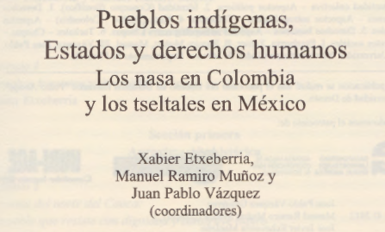

Exercise 2.

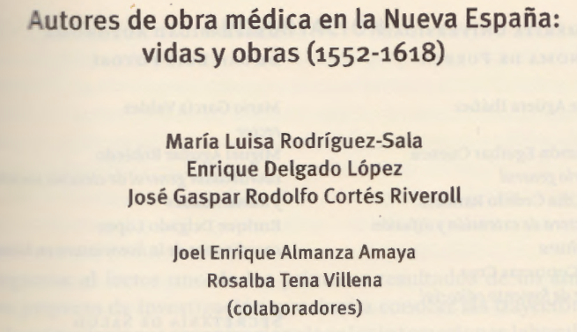

Exercise 3.

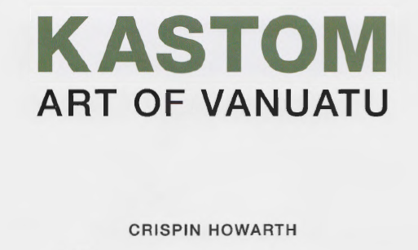

Exercise 4.

