RDA Training, Personal Names – Exercise 2

How could we spruce up this record under RDA?

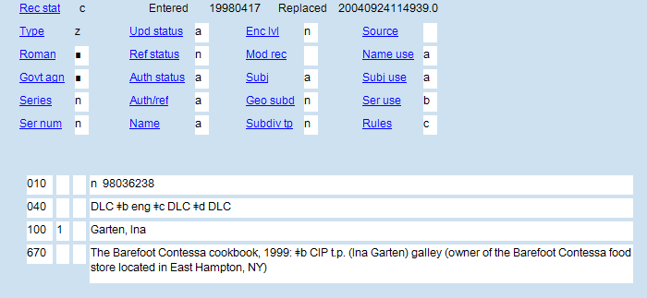

__________________________________________________________________________________________________
__________________________________________________________________________________________________
__________________________________________________________________________________________________
__________________________________________________________________________________________________
__________________________________________________________________________________________________
__________________________________________________________________________________________________
__________________________________________________________________________________________________
__________________________________________________________________________________________________
__________________________________________________________________________________________________
__________________________________________________________________________________________________
__________________________________________________________________________________________________
__________________________________________________________________________________________________
__________________________________________________________________________________________________

Ina Garten
From Wikipedia, the free encyclopedia

Ina Rosenberg Garten is an American author, host of theFood Network program Barefoot Contessa, and former White House nuclear policy analyst.
Born | Ina Rosenberg  February 2, 1948 (age 64)  Brooklyn, New York
Education | Syracuse University  George Washington University

Born Ina Rosenberg, in Brooklyn, New York, and raised in Stamford, Connecticut, Garten was one of two children born to Charles H. Rosenberg, a surgeon specializing in otolaryngology, and his wife, Florence.
On December 22, 1968, Rosenberg and Garten were married in Stamford, and soon relocated to Fort Bragg, North Carolina.
In Washington, Garten worked in the White House and took business courses at George Washington University, eventually earning an MBA, while her husband worked in the State Department and completed his graduate studies. Originally employed as a low-level government aide, she climbed the political ladder to the Office of Management and Budget and was assigned the position of budget analyst, which entailed writing the nuclear energy budget and policy papers on nuclear centrifuge plants for Presidents Gerald Ford and Jimmy Carter.
Garten left her government job in 1978 after spotting an ad for a 400-square-foot (37 m²) specialty food store in East Hampton, New York. The store was named Barefoot Contessa. She made a hasty decision to purchase the store after traveling to view it, and moved to New York to assume ownership and management.
Under the guidance of her husband, Garten reemerged in 1999 with her attention turned to publishing. She carried on the Barefoot Contessa name in her 1999 sleeper bestseller, The Barefoot Contessa Cookbook.
After the success of The Barefoot Contessa Cookbook and Barefoot Contessa Parties!, Garten was approached by Food Network with an offer to host her own television cooking show. She rejected this proposal several times, until the London-based production company responsible for the popular Nigella Bites was assigned to the deal. She acquiesced to a 13-show season, and Barefoot Contessa premiered in 2002 to a positive reception.
Her husband, Jeffrey Garten, went on to become the Undersecretary of Commerce for International Trade and dean of the Yale School of Management. He is now the Juan Trippe Professor in the Practice of International Trade, Finance, and Business at Yale. He can also frequently be seen on her cooking show, assisting his wife with simple tasks or sampling the dishes she has created. They divide their time among Manhattan, East Hampton, and Paris.

