RDA Training, Corporate Names – Exercise 2
How could we spruce up this record under RDA?
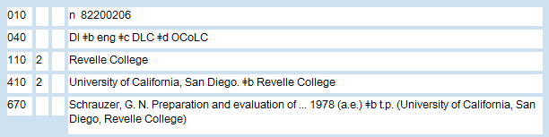
_____________________________________________________________________________________
_____________________________________________________________________________________
_____________________________________________________________________________________
_____________________________________________________________________________________
_____________________________________________________________________________________
_____________________________________________________________________________________
_____________________________________________________________________________________
_____________________________________________________________________________________
_____________________________________________________________________________________
_____________________________________________________________________________________
_____________________________________________________________________________________
_____________________________________________________________________________________
_____________________________________________________________________________________
_____________________________________________________________________________________
_____________________________________________________________________________________
_____________________________________________________________________________________
_____________________________________________________________________________________

Revelle College
From Wikipedia, the free encyclopedia

Revelle College was the first college founded at the University of California, San Diego, and named after oceanographer Roger Revelle (who was instrumental in founding UCSD out of the Scripps Institution of Oceanography) in 1964. Of the initial class of 181 undergraduate students, all but 30 were science majors. UCSD—and, with it, Revelle College—was founded at height of the Space Race between the United States and the Soviet Union. Revelle College remains focused on developing "a well-rounded student who is intellectually skilled and prepared for competition in a complex world."
Revelle's general education requirements are both rigorous and highly structured and attempt to follow the traditions of a classic liberal arts college. Revelle's stated goal of creating "Renaissance scholars" is reflected in their general education requirements, which ensure that a student graduating from the college has experienced a wide array of subjects from a year of calculus to proficiency in a foreign language. Revelle College's core writing course is known as Humanities (HUM), and is a notoriously challenging Western Civilization course that incorporates writing, history and other social science requirements into a five quarter (1²⁄₃ year) sequence that attempts to understand the greater social and literary developments throughout Western culture.
In 2004–2005, the college celebrated its 40th anniversary.

