FRBR Exercises: Applying the Concepts – Single Manifestation Exercise 1

Meryle Secrest's Frank Lloyd Wright: A Biography focuses on Wright's family history, personal adventures, and colorful friends and family. Secrest had unprecedented access to an archive of over one hundred thousand of Wright's letters, photographs, drawings, and books. She also interviewed surviving devotees, students, and relatives. The result is an explicit portrait of both the genius architect and the provocative con-man.

Title: Frank Lloyd Wright
Author: Meryle Secrest
Publisher: Knopf
Publication Date: 1992
Edition: 1st Edition
Original language: English
Physical details: Hardback, xviii, 634 p., 121 ill.
Genre: Biography

ISBN: 0394564367

UCSD has: two copies, shelved in the Arts Library as NA737.W7S32 1992, with barcodes 21822659001 and 21822658902

FRBR Exercises: Applying the Concepts – Multiple Manifestations Exercise 2

Dragonfly in Amber, the second book in the best-selling Outlander series, is written by Diana Gabaldon. It is a love story set in Scotland involving time travel.

Title: Dragonfly in Amber  Publisher: Delacorte Press  Publication Date: 1992  Edition: 1st Edition  Original language: English  Physical details: Hardback 743 pages  Genre: Speculative fiction, Romance novel, Fiction, Historical novel  ISBN 10: 0385302312  ISBN 13: 9780385302319  LC copy has one copy with autograph:  PS 3557 .A22 D73 1992 | Title: Dragonfly in Amber  Publisher: Delta Trade paperback  Publication Date: 2001  Language: English  Physical details: Paperback 768 pages  ISBN: 0385335970  ISBN 13: 9780385335973  LC has one copy:  PS 3557 .A22 D73 2001

Title: Dragonfly in Amber
Publisher: Random House Publishing Group
Publication Date: October 2004
Physical details: Ebook -- 963 pages downloaded as PDF
eISBN: 9780440335184
LC has licensed this ebook

FRBR Exercises: Applying the Concepts -- Translation Exercise 3

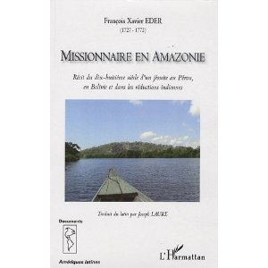

Descriptio provinciae Moxitarum in regno peruano written by Francisco Javier Eder. It’s a description of a Jesuit’s missionary work with the Mojo Indians in Peru. It has been translated into French and Spanish and published multiple times. It was originally published in 1791 in Latin.

Title: Missionnaire en Amazonie : recit du dix-huitieme siecle d'un jesuite au Perou,
en Bolivie et dans les reductions indiennes / François Xavier Eder; traduit du latin par Joseph Laure.
Translation of: Descriptio provinciae Moxitarum in regno peruano
Publisher: Harmattan, Paris
Publication Date: 2009
Physical details: 459 p. : ill. ; 24 cm
Language: French

LC Barcode: 00285757174
Title: Descripción de Ia provincia de los mojos en el reino del Perú : sacada
de los escritos póstumos del P. Francisco Javier Eder I arreglada e
ilustrada con notas por el abate y consejero real, Mako ; traducida del latin por
Fray Nicolas Armentia.
Publisher: El Siglo industrial, La Paz, Mexico
Publication Date: 1888
Physical details: 178 p. ; 23 cm.
Language: Spanish
LC copy has binder’s title: Mojos/Armentia
LC Barcode: 00005678699

FRBR Exercises: Applying the Concepts -- Compilation Exercise 4

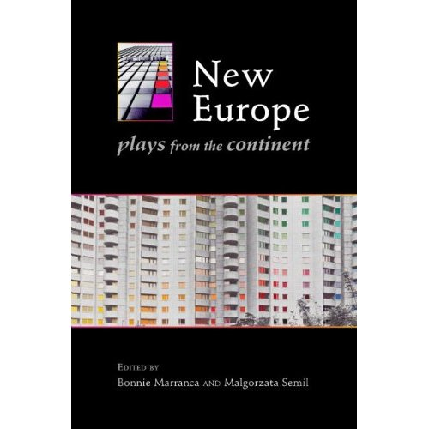

New Europe: Plays from the Continent is a collection of seven plays that explore issues of terrorism, immigration, youth, globalization, families, and post-communist culture in the years since the fall of the Berlin Wall and expansion of the European Union.

Title: New Europe: plays from the continent
Editors: Bonnie Marrance and Małgorzata Semil
Publisher: PAJ Publications, New York
Distributor: Consortium Books Sales and Distribution, Minneapolis, Minn.
Publication Date: 2009
Language of publication: English
Original languages: German, Polish, Czech, Spanish and Norwegian
Physical details: Paperback, xii, 399 p.

ISBN 13: 9781555540852
It includes:
Igor Bauersima, norway.today (Switzerland)
Malgorzata Sikorska-Miszczuk, The Death of the Squirrel-Man (Poland)
Goran Stefanovski, Hotel Europa (Macedonia)
Petr Zelenka, Tales of Ordinary Madness (Czech Republic)
Roland Schimmelpfennig, Push Up 1-3 (Germany)
Juan Mayorga, Hamlyn (Spain)
Jon Fosse, Sa ka la (Norway)
UCSD has one copy shelved on Geisel Floor 7 as PN6112 .N46 2009

FRBR Follow-up 1: Practicum: Applying the Concepts – Accompanying Materials Exercise 5

Mastering ArcGIS is an introduction to GIS software and its basic elements. It’s a step-by-step course. It was originally published in 2004 in English.

Title: Mastering ArcGIS
Author: Maribeth Price
Publisher: McGraw Hill, Dubuque, IA
Publication Date: 2006
Edition: 2nd ed.
Original language: English
Physical details: xiii, 609 pages : illustrations ; 28 cm.
ISBN: 9780072984170 (hard copy)
ISBN: 9780072984187 (CD-ROM) (Video clips with audio instructions, data for following tutorials and completing exercises)
UCSD has one copy in Geisel stacks as G70.212.P74 2006
Barcode 31822032471369

FRBR Exercises: Applying the Concepts – Conference Proceedings Exercise 6

Silicon Science and Advanced Micro-Device Engineering II—selected papers from the 6th International Symposium on Silicon Science and 2nd International Conference on Advanced Micro-Device Engineering, December 9-20, 2010, Kiryu City Performing Arts Center, Kiryu, Japan.
A collection of 39 peer-reviewed papers imparting the latest findings related to silicon science and advanced micro-device engineering. The papers are on: Materials Science; Chemical Science and Technology; Nano-Science and Technology; Photonic Devices and Technology; Novel Measurement and System Technology; Information and Communication Engineering.

UCSD has one copy of hardback and ebook.
Title: Silicon Science and Advanced Micro-Device Engineering II
Editors: Osamu Hanaizumi, Masafumi Unno and Kenta Miura
Publisher: Trans Tech Publications Ltd.
Publication Date: 2011
Language: English
Physical details: Hardback: x, 312 pages

ISBN 13: 9783037852859

Barcode: 31822039139464
Title: Silicon Science and Advanced Micro-Device Engineering II
Publisher: Trans Tech Publications Ltd.
Publication Date: 2012
Language: English
Ebook: 320 pages download in PDFs (1 PDF per article)
eISBN: 9783038136828
Provider: http://dx.doi.org/10.4028/www.scientific.net/KEM.497

This work is also available on CD from Trans Tech Publications
Title: Silicon Science and Advanced Micro-Device Engineering II
Publisher: Trans Tech Publications Ltd.
Publication Date: 2012
Language: English
Electronic: 1 CD-ROM
ISBN-13: 9783038136828

FRBR Exercises: Applying the Concepts -- Map Exercise 7

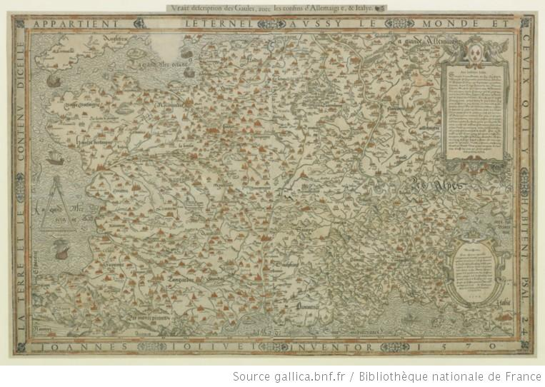

Vraie description des Gaules, avec les confins d'Allemaigne et Italye. A map created by Jean Jolivet to depic Gaules (i.e. Gaul). During Roman times, Gaul was a region of western Europe occupied approximately by present-day France, Belgium, the western part of Switzerland and the parts of the Netherlands and Germany on the west bank of the Rhine river. It was originally printed in 1570 in French.

Title: Vraie description des Gaules, avec les confins d'Allemagne, et Italye
Publisher: M. du Chesne, Paris
Publication Date: 1570
Language: French
Physical details: 1 sheet: 85 x 55 cm
Scale: 1:2 300 000 ca.
Bibliotheque Nationale de France has print and electronic copies
Access Address: http://gallica.bnf.fr/ark:/12148/btv1b550003302

Title: Vraie description des Gaules, avec les confins d'Allemagne, et Italye
Publisher: Éditions d’Hier et Demain, Paris
Publication Date: 1974
Language: French
Coordinates: W 05°00ʹ--E 08°00ʹ/N 51°00ʹ--N 42°30ʹ
Facsimile: 1 sheet, 62 x 93 cm
University Laval Bibliotheque has a facsimile copy
Call no.: GE C- 4877 (RES)

FRBR Exercises: Applying the Concepts – Musical score Exercise 8

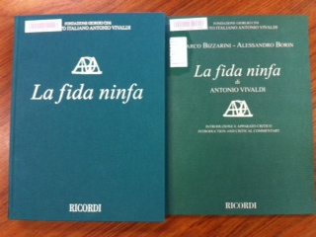

La fida ninfa is an opera by Antonio Vivaldi. It was premiered at the opening of Verona’s Teatro Filarmonico in January 1732. The opera is for solo voices (SSAATBarB), chorus (SATB), and orchestra. “The opera is an allegory on matrimonial love replete with love-struck nymphs, grumpy pirates and multiple cases of mistaken identity... While it is a credit to the composer that he was still able to create an impressive work from this clichéd literary material, the lack of a convincing plot line weakens the overall impact of the opera.”

Title: La fida ninfa
Composer: Antonio Vivaldi
Librettist: Francesco Scipione
Publisher: Ricordi
Publication Date: 2012?
Copyright Date: c2012
Edition: Edizione critica delle opera de Antonio Vivaldi, da cura di Marco Bizzarini, Alessandro Borin
Original language: Italian
Genre: Opera
Physical details: Full score (xxiv, 289 p.); critical commentary (94 p.) in a separate volume
“The score includes a preface and the critical commentary includes historical notes and synopsis in Italian with English translations by Michael Talbot.”
Edited from the holograph in the Biblioteca nazionale universitaria di Torino
Italian words
Facsimile of complete libretto on pp. 277-289 of score

ISMN: 9790041914084

UCSD has: one copy in two volumes, shelved in the Arts Library as M1500.V68 F5 2012

FRBR Exercises: Applying the Concepts – Sound recording Exercise 9

Drive American: A superlative program of piano music by American composers is offered by pianist Heidi Williams. The oldest work on the program dates from 1988 (William Bolcom) and the most recent was written in 2009 (Daniel Crozier), giving us a snapshot of what American composers have been writing for piano in the past 25 years.

Title: Drive American
Performer: Heidi Louise Williams
Publisher: Albany Records
Publication Date: 2011
Physical details: Audio CD

Label no.: TROY1298

All works for piano

Recorded May 16-19 and July 26-27, 2009 in Opperman Music Hall, Florida State University

Includes:

American berserk by John Adams

No longer very clear by Joan Tower

Winter aubade by Daniel Crozier

Ba ban by Yi Chen
Traces by Augusta Read Thomas

Vers le silence by William Bolcom

Hi-jinks from New Etudes by Willliam Bolcom

Hymne a l’amour from new Etudes by William Bolcom

UCSD has one copy in limited circulation in the Arts Library, shelved as MUD 92806

FRBR Follow-up 1: Practicum: Applying the Concepts -- Video Exercise 10

Dance in America. Everybody dance now: Through footage, interviews, and video clips, this documentary explores the phenomenon and impact of dance in music videos. Numerous choreographers and performers, such as Martin Scorsese, Michael Kidd, Madonna, Michael Jackson, Paula Abdul, MC Hammer, James Brown and Janet Jackson, offer comments on creating music videos out of the melting pot of today's dance styles, as well as the concepts behind their work.

It is part of Great Performances, a television series devoted to the performing arts, has been telecast on Public Broadcasting Service (PBS) public television since 1972. The show is produced by WNET in New York City (originally in conjunction with KQED San Francisco, WTTW Chicago, Maryland Public Television, South Carolina ETV and KERA-TV Dallas/Fort Worth).

Title: Dance in America. Everybody dance now
Creators: A production of Thirteen-WNET ; presented by WNET, KERA, KQED, MPT, SCETV, and WTTW
Creators: Directed and produced by Margaret Selby ; written by Jennifer Dunning
Series: Great performances
Publisher: United States : WETA-TV
Release date: 1991-10-02 at NETWORK: PBS WNET, New York, NY
Language: English
Physical details: 1 videocassette (ca. 60 min.) : sd., col. ; 3/4 in.
LC has a viewing copy.

FRBR Exercises: Applying the Concepts -- Serial Exercise 11

Cataloging & Classification Quarterly

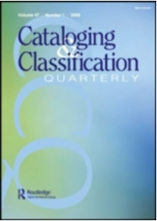
Cataloging & Classification Quarterly is respected as an international forum for discussion in all aspects of bibliographic organization. It presents a balance between theoretical and applied articles in the field of cataloging and classification, and considers the full spectrum of creation, content, management, and use and usability of both bibliographic records and catalogs. This includes the principles, functions, and techniques of descriptive cataloging; the wide range of methods of subject analysis and classification; provision of access for all formats of materials; and policies, planning, and issues connected to the effective use of bibliographic records in modern society. All papers in Cataloging & Classification Quarterly journal have undergone editorial screening and peer review.
Beginning in 2009 with volume 47, Cataloging & Classification Quarterly is published eight times per calendar year by Taylor & Francis.

Title: Cataloging & Classification Quarterly
ISSN: 0163-9374 (Print), 1544-4554 (Online)
Publication Frequency: 8 issues per year (2009-)
Publisher:
- Print:
[c1981]-: New York, N.Y. : ǂb Haworth Press,
2009-: Philadelphia, PA : ǂb Routledge, Taylor & Francis Group
- Online: Taylor & Francis Group
UCSD has:
- Print: v. 11-28, 45-46 (1990-2008) as Z693.A15 C35 shelved in SRLF
- Online: v. 23 (1997)- Restricted to UCSD IP addresses
FRBR Exercises: Applying the Concepts – Book + Movie Exercise 12

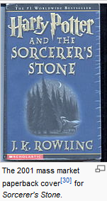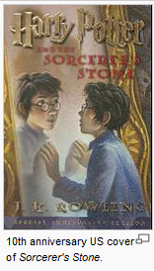

The book, Harry Potter and the Philosopher's Stone, which is J.K. Rowling's debut novel, was published on 26 June 1997 by Bloomsbury in London. In 1998 Scholastic Corporation published an edition for the United States market under the title Harry Potter and the Sorcerer's Stone.

The first novel in the Harry Potter series written by J. K. Rowling and featuring Harry Potter, a young wizard. It describes how Harry discovers he is a wizard, makes close friends and a few enemies at the Hogwarts School of Witchcraft and Wizardry, and with the help of his friends thwarts an attempted comeback by the evil wizard Lord Voldemort, who killed Harry's parents when Harry was one year old.

Manifestation that UCSD owns
Title: Harry Potter and the Sorcerer's Stone
Author: J. K. Rowling
Illustrator: Mary GrandPré
Publisher: New York : A.A. Levine Books
Publication Date: 1998
Edition: 1st American ed.
Language: English
Physical details: vi, 309 p. : ill. ; 24 cm.
ISBN: 0590353403 (hardcover); 059035342X (pbk.)
UCSD has two copies as PR6068.O93 H38 1998 with barcode: 31822029722618 & 31822035273895

Manifestations that UCSD doesn’t own
Title: Harry Potter and the Sorcerer's Stone  Author: J. K. Rowling  Publisher: New York : A.A. Levine Books  Publication date: 2001  Binding: Mass Market Paperback  Language: English  Physical details: 400 p.  ISBN-13: 9780439362139  UCSD has no copy | Title: Harry Potter and the Sorcerer's Stone  Author: J. K. Rowling  Publisher: New York : Scholastic Inc.  Publication date: 2008  Edition: 10th Anniversary Edition [Deluxe Edition]  Language: English  Physical details: 320 p.  ISBN-13: 9780545069670  UCSD has no copy

Translations:
Title: Harry Potter and the Philosopher's Stone  Translation title: Hali Bote yu mo fa shi (哈利·波特与魔法石)  Author: J. K. Rowling  Translator: Nong Su (苏农)  Publisher: Beijing : Ren min wen xue chu ban she  Publication date: 2000  Edition: Beijing di 1 ban  Series: Hali Bote ; 1  Language: Chinese  Extent: 191 p.  ISBN-13: 9787020033430 | Title: Harry Potter and the Philosopher's Stone  Translation title: Harry Potter y la piedra filosofal  Author: J. K. Rowling  Translator: Alicia Dellepiane  Publisher: Barcelona : Salamandra  Publication date: c2001  Edition: 1a. ed.  Series: Serie Harry Potter ; 1  Language: Spanish  Physical details: 254 p.  ISBN-13: 9788478886548

Movie:
Title: Harry Potter and the Sorcerer's Stone
Author: J. K. Rowling
Screenplay by Steve Kloves ; produced by David Heyman ; directed by Chris Columbus
Publisher: [Burbank, Calif.] : ǂb Warner Home Video
Publication date: c2002 (Movie originally released in 2001)
Edition: Special widescreen ed.
Language: English and Spanish with subtitles in English and Spanish; Closed-captioned
Physical details: 2 DVDs (152 min.) : ǂb sd., col. ; ǂc 4 3/4 in. (Region 1) (Disc 1. Movie -- disc 2. special features)
ISBN-13: 9780790767352
Publisher no.: 22467 (Warner Home Video)
Title: Harry Potter and the Sorcerer's Stone (disc 1 in set: Harry Potter. years 1-6)
Author: J. K. Rowling
Screenplay by Steve Kloves ; produced by David Heyman ; directed by Chris Columbus
Publisher: Burbank, CA : Distributed by Warner Home Video
Publication date: 2009
Edition: Widescreen ed
Physical details: 6 DVDs (914 min.) : sd., col. ; 4 3/4 in
Language: English and Spanish with subtitles in English and Spanish; Closed-captioned
ISBN-13: 9781419866845
Publisher no.: 3000016276
UCSD owns the set as FVLDV 8715-6 disc 1 with Barcode 31822036680569

