Converting the PURL validation results into a usable format
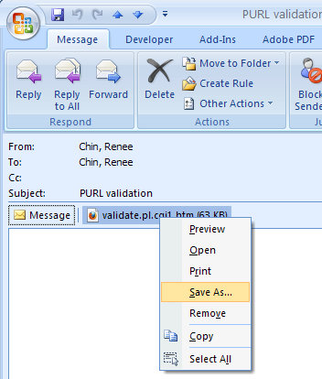
- The PURL validation reports are in HTML format and will be sent via email as attachments. Save the attachments by right-clicking on the documents in your email message and choosing “Save As…”. Choose a location to save the attachment and click Save.

- Using Internet Explorer, go to: http://tpot.ucsd.edu/cgi-bin/prod/bibpurl_reformat.cgi

- Work with one report at a time. Click Browse to find the PURL validation report you want to work on. Click Open. Then click Process File.
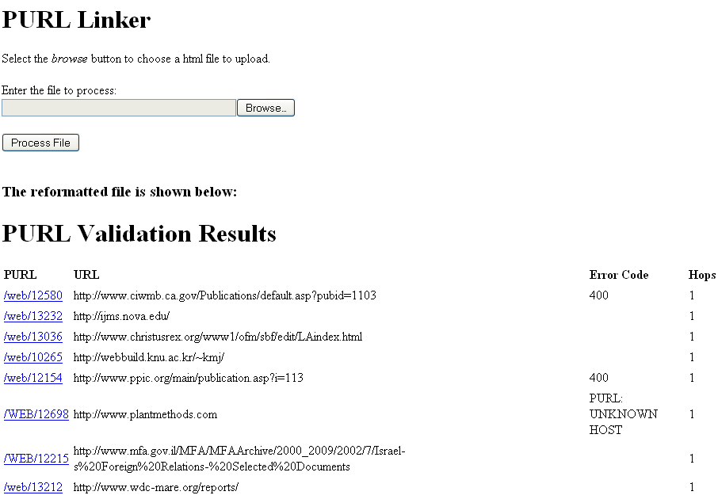

- Your PURL validation results will automatically get hyperlinked and the individual columns (PURL, URL, Error code, Hops) can also be sorted by clicking on the column names. When you click on the column names, a little down-arrow will appear to indicate the column that is being sorted. This is especially helpful for grouping domains or error codes together.
How to check for broken links
There are many ways to check the validation report but here is one way:
- If you have a mouse with a scroll wheel, use it to click on a few of the hyperlinked PURLs to open them in different tabs. Be careful not to open too many tabs as this will crash your browser.
- In the upper left corner, there is an icon that looks like this: (this is the QuickTab feature which is only available in IE). Click on this icon after opening your windows to see broken links at a glance. These are the PURLs you need to fix. You can also click on each page in the display to view it in full screen. Toggle between the displays by clicking on the QuickTab icon.
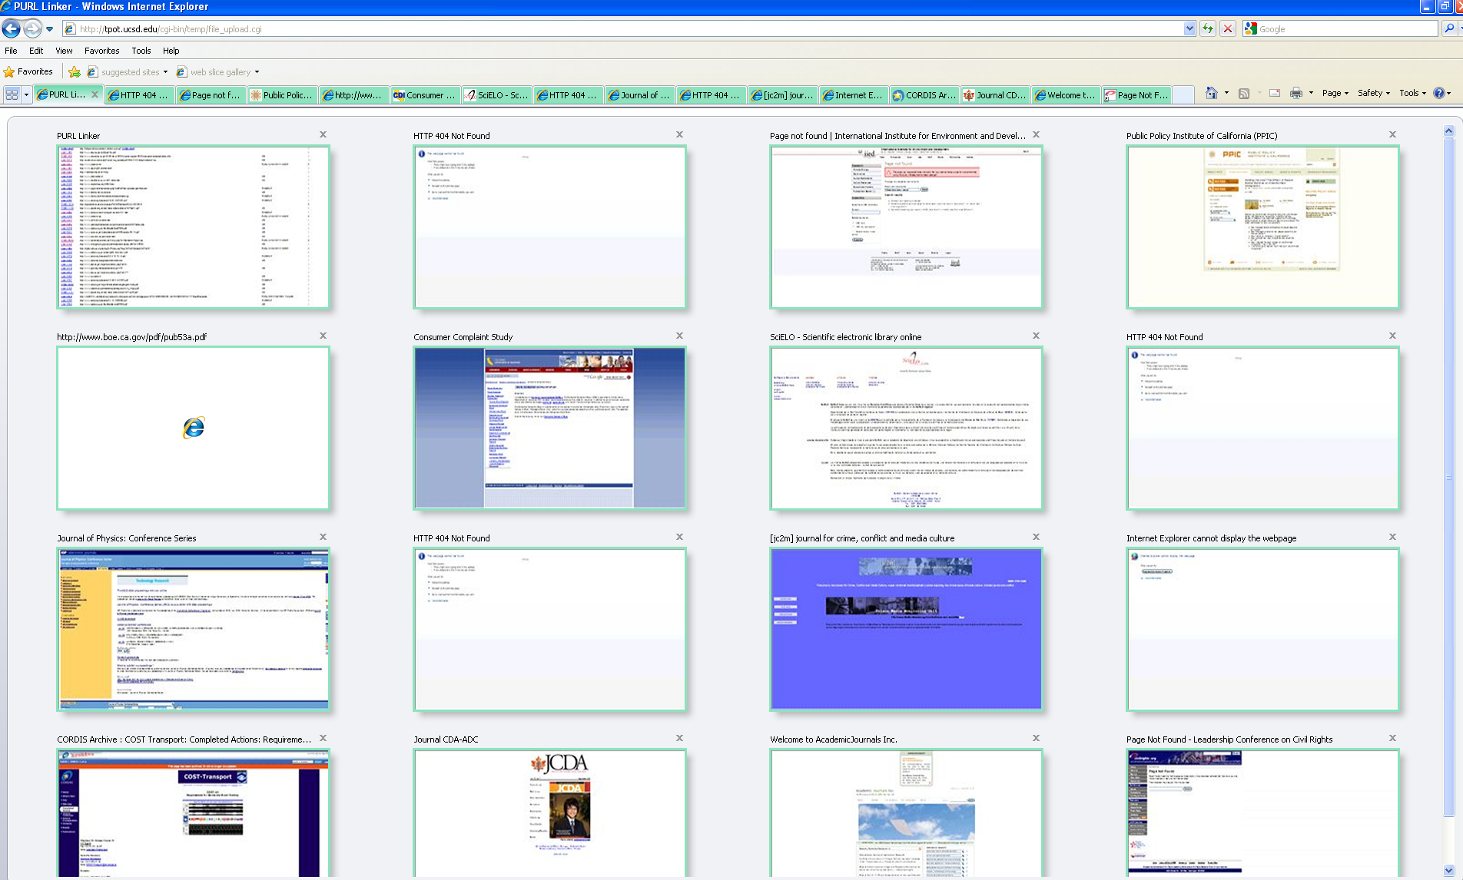

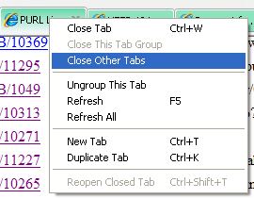
- When finished, right-click on the PURL linker tab
and choose Close other tabs. You can repeat
steps 1-2 until you’ve gone through the entire
report. Find new URLs for the broken links if
possible.

- Compile the broken links onto a spreadsheet with the PURL number in one column and the corresponding new valid URL in another column. If the resource is no longer available online, or if you cannot find a link for the exact online equivalent (e.g., the resource has been replaced by a newer edition, archive content no longer available), please indicate this on the spreadsheet. Indicate other concerns in the “New URL” column as needed. Send the spreadsheet by email to Renee for batch modification.
