Deleting OCLC holdings for SCP monographs (including holdings symbol “merer”)
Last updated: 141118

(For instruction on deleting serial holdings/LHR’s, please see document: Deleting LHR’s for SCP Serials
PART A, deleting all holdings for monographs except “merer”
- Log into the Connexion client using the SCP agent authorization.
- Pull up your record.
- Add the appropriate holdings symbols you want deleted in the 951 field, all 10 or any combination of them. NOTE IF YOU NEED TO DELETE MERER (UCM’s) HOLDINGS YOU WILL NEED TO FOLLOW PART B as well, since they add LHR’s for monographs.
- Press Shift-F8 to delete holdings.
- If merer holdings/lhrs are not attached, you will get a dialog box like this (note number of holdings may vary):
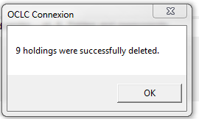

- If merer holdings are attached , you will get a dialog box with similar info below, if this is the case, go to part B
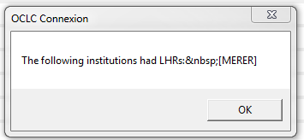

Part B, deleting the “merer” holdings
- Normally holdings have been deleted at this point EXCEPT FOR MERER. Merer holdings and their LHR will still be attached.
- Click “OK”, go back and add “merer” only to the 951 and press Shift-F8 again and you will get the dialog box:
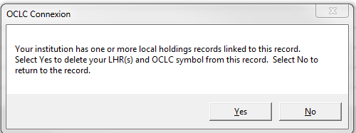

- Click “Yes” to delete the “merer” holdings
- Double-check to see that holdings have been deleted.

According to OCLC: “If you have a significant number of records from which to delete holdings, request a batchload project to delete the holdings. If you have a cataloging subscription, you can get the batch project at no extra cost, but you give up the credits that you would have received by doing the work online.”

