Deleting LHR’s for SCP serials
Last reviewed: 151113
(note: this procedure is also part of SCP Procedures for Creating and Deleting LHR’s)
If we are entirely removing a title from SCP (i.e., access no longer available)
- Put a 951 in the record with the appropriate er-holdings codes, then hit Shift-F8 to delete the holdings for the campuses. You will get a dialog box
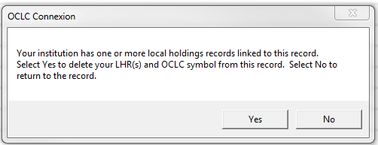
- Click “Yes” to delete the holdings. Verify that holdings/LHRs have been removed. If holdings still exist repeat step with proper scper codes since if you don’t put in the exact holdings to delete, this will not work properly.

If we are dropping one or more campuses from a title and that title has no other access for that campus or campuses (i.e., UCB drops out of a tier 1 resource which is the only UCB access for that resource):
- Catalogers will make changes to the bib record, including changing the 856|z and removing the 920 for UCB.
- A 599 UPD note will be added to the bib and the record will be resent to the remaining 9 campuses.
- The cataloger will then need to manually delete UCB’s holdings and LHR from the OCLC record for that title by putting a 951 in the record with the appropriate er-holdings code, then deleting the holdings for that campus. OCLC will ask if you’d like to delete the LHR associated with this campus, and you can hit “yes.”
- New LHR’s will be resubmitted for the other 9 campuses still having access to the title in the weekly LHR process. New LHRs will reflect update info, i.e., that this title is now a tier 2 with the nine remaining campuses listed as having access.
Note that usually when a campus drops out of an entire package, an e-mail is sent to the campus to delete all titles contained within that package.
According to OCLC: “If you have a significant number of records from which to delete holdings, request a batchload project to delete the holdings. If you have a cataloging subscription, you can get the batch project at no extra cost, but you give up the credits that you would have received by doing the work online.”

