BibPURLs—Batch modification

In the PURL server, search for the URL syntax of the PURLs you wish to modify. Copy and paste the results into an Excel file. Clean up the results so that the PURL is in one column and its associated URL is in the 2nd column:
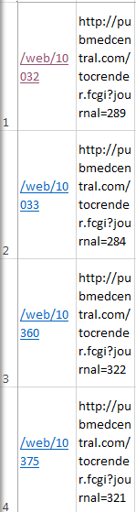

Copy the PURL/URL and paste it into Word as text (“Paste special” as Unformatted Text). Now you will need to create a XML file of the data to feed into the PURL server.
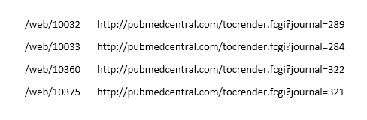
To create the XML file in Word, find/replace the following text in this order:
Find: ^p
Replace: </url>^p<type>Batch_Modified</type>^p<note>URL changed</note>^p</rec>^p

Find: ^t
Replace: </purl>^p<url>

Find: /web/
Replace: <rec>^p<purl>/web/

Find: </url></url>
Replace: </url>

Find: [Old URL syntax you want to replace]
Replace: [New URL syntax you want to replace]
Make sure you add the correct syntax according to the identifier placement. Sometimes this step has to be done twice, if there is text after the identifier that needs to be added, deleted, or replaced.

Delete any blank entries at the end of the document (where there is no URL). Sometimes extra lines will get XML treatment.

Add <recs> at the very top of the file
Add </recs> at the very bottom of the file

Copy/paste list into Batch modify PURLs form. Click “Process request.”
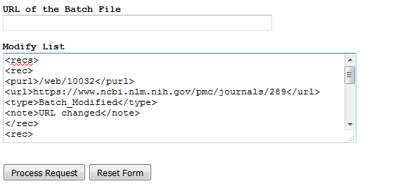

Sample XML File after creating it in Word:
<recs>
<rec>
<purl>/web/10032</purl>
<url>https://www.ncbi.nlm.nih.gov/pmc/journals/289</url>
<type>Batch_Modified</type>
<note>URL changed</note>
</rec>
<rec>
<purl>/web/10033</purl>
<url>https://www.ncbi.nlm.nih.gov/pmc/journals/284</url>
<type>Batch_Modified</type>
<note>URL changed</note>
</rec>
<rec>
<purl>/web/10360</purl>
<url>https://www.ncbi.nlm.nih.gov/pmc/journals/322</url>
<type>Batch_Modified</type>
<note>URL changed</note>
</rec>
</recs>

