**UCSD online journals and databases workflow – summary**

This is a summary of the current workflow for cataloging UCSD online journals and databases in Alma. Workflows are still in flux and this document does not address the issue of notifications or the e-activation task list or ejournals in aggregator packages and collections.

New licensed ejournals (selected titles only):

Titles migrated from Millennium are more likely to have bibs, portfolios, and PO lines that aren’t linked properly. Going forward, there should be fewer discrepancies.

1. All licensed ejournals will have portfolios before they are sent to MS for cataloging.
   1. CARS will search for and activate CZ portfolios if available. If activated, the CZ record will be linked to the IZ.
   2. If a CZ portfolio is not available, CARS will create a local portfolio. (NOTE: This local portfolio may be linked to a CZ record. If a CZ record isn’t available, the local portfolio will be linked to a brief bib created by CARS)
   3. CARS may create a PO line for the new ejournal (NOTE: Some ejournals, especially those in big packages, may not have individual PO lines and instead have one PO line associated with the collection only)
   4. CARS will send cataloging request to MS via email.
2. MS will catalog serial.
   1. MS will determine whether the local portfolio should be standalone or added to an existing electronic collection. If added to an electronic collection, do not contribute it to the CZ. (NOTE: If a CZ portfolio becomes available later, delete the local portfolio and link the CZ one—*workflow still TBD*)
   2. MS will relink the electronic portfolio to a different bib, if needed.
   3. MS will relink PO lines to the correct portfolio, if needed.
   4. MS will catalog any hidden title changes, and create local portfolios as needed. Local portfolios may be standalone or added to existing electronic collections but not contributed to the CZ.

New open access ejournals:

Open access ejournal collections in the CZ are activated by default. As a result, it is necessary to search both Alma and Primo to determine whether an ejournal is already available or still needs to be cataloged/activated.

If an open access ejournal portfolio is not available in the CZ, cataloging requests may be submitted by CARS or selectors via the form, [Request to catalog an Internet resource (UCSD Libraries selectors only)](http://tpot.ucsd.edu/description/electronic/coldev.html).

**If unsure, submit a cataloging request:** [**Request to catalog an Internet resource (UCSD Libraries selectors only)**](http://tpot.ucsd.edu/description/electronic/coldev.html) **and MS will investigate.**

Alma IZ checklist:

Search for the title in the Alma IZ. If you get a match, and the record has all of the following, consider it cataloged. No further action is needed.

1. “Electronic” green icon.
2. Active portfolio for a free e-journals (e.g., Free e-journals, Open access …, etc.) or local portfolio.
3. The jkey/URLin the portfolio matches the one for the cataloging request.

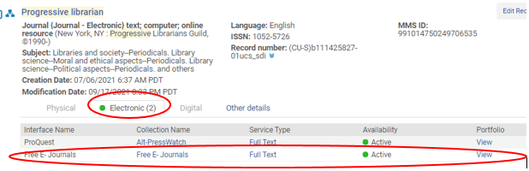

If the record doesn’t meet all of the above criteria, check the NZ for possible titles cataloged/activated by SCP.

Alma NZ view checklist:

Search for the title in the Alma NZ. If you get a match, and the record has all of the following, consider it cataloged. No further action is needed.

1. “Electronic” green icon **and/or** “Held by…” My institution.
   1. “Electronic” green icon = activated by SCP.

or

* 1. “Held by…” My institution = activated locally by UCSD (may be CZ or local portfolio).

1. Active portfolio for a free e-journals (e.g., Free e-journals, Open access …, etc.) or local portfolio.
2. The jkey/URLin the portfolio matches the one for the cataloging request.

If the record doesn’t meet all of the above criteria, submit a cataloging request: [Request to catalog an Internet resource (UCSD Libraries selectors only)](http://tpot.ucsd.edu/description/electronic/coldev.html) and MS will catalog.

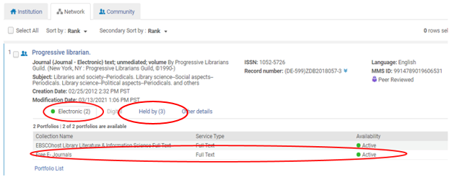

Primo view checklist:

Search for the title in Primo/UC Search. If you get a match, and the record has all of the following, consider it cataloged. No further action is needed.

1. Free e-journals target (e.g., Free e-journals, Open access …, etc.) appears under “View online/full text availability.”
2. Click on the access to check the URL to see if it matches the one in the cataloging request.

If the URL doesn’t match, submit a cataloging request: [Request to catalog an Internet resource (UCSD Libraries selectors only)](http://tpot.ucsd.edu/description/electronic/coldev.html) and MS will catalog.

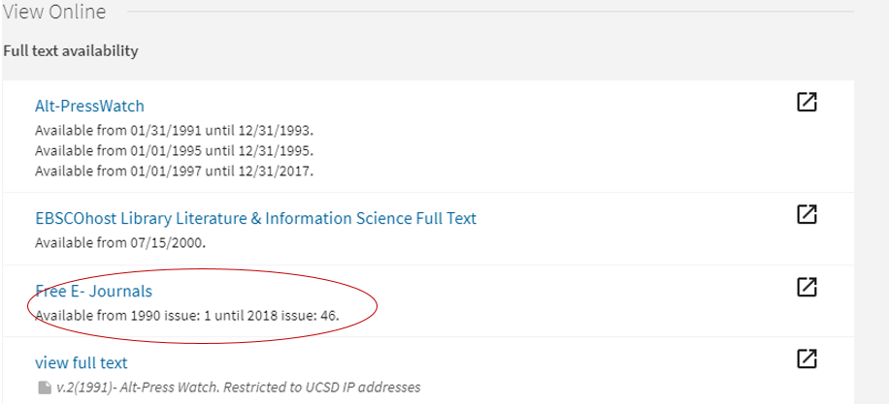

New databases (licensed):

1. CARS will activate an existing CZ portfolio or electronic collection or create a local one.
   1. **Guiding principles:** If there a CZ portfolio or electronic collection record for the resource **and it has the correct URL**, use it regardless of Ex Libris’ supplied resource type (e.g., book, journal, database, website, etc.). Avoid using the BACON and JISC collections. If those are the only options, create a local collection instead.
      1. **Websites and databases with CZ portfolios**: Activate it, if it has the correct URL, regardless of Ex Libris’ supplied resource type
      2. **Websites and databases with CZ electronic collection records**: Activate it, if it has the correct URL, regardless of Ex Libris’ supplied resource type
      3. **Databases without full text service (i.e., not in CZ)**: Create local electronic collection record as resource type: Database. This can be changed later to full text service if needed (see instructions* at the end of this document).
      4. **Websites without full text service (i.e., not in CZ)**: Create local electronic portfolio as resource type: Website.
      5. **Websites and databases with full text service (i.e., not in CZ)**: Create local electronic collection record as resource type: Aggregator or Selective package--Full text or Selected full text
   2. CARS may bring in a CZ bib or create a brief record for the purposes of ordering or PO lines.
   3. CARS may create a PO line for the database.
   4. CARS will a send cataloging request to MS via email, providing the electronic portfolio or collection PID.

Example: Since Ex Libris’ has their own definitions and framework for bibliographic data, you may see things like this that don’t make sense. This resource is technically a website. In the cataloging world, websites are cataloged as “serials.” However, the cataloging treatment doesn’t dictate the resource type in Alma (it’s unclear how resource types are determined) so there could be portfolios or collection records in the CZ for any given resource. As it turns out, Ex Libris considers this an ebook. It has an ebook portfolio in the CZ and since the URL matches the cataloged resource, we would activate and use it. If there was no portfolio in the CZ, we would have created a local portfolio with resource type: Website.

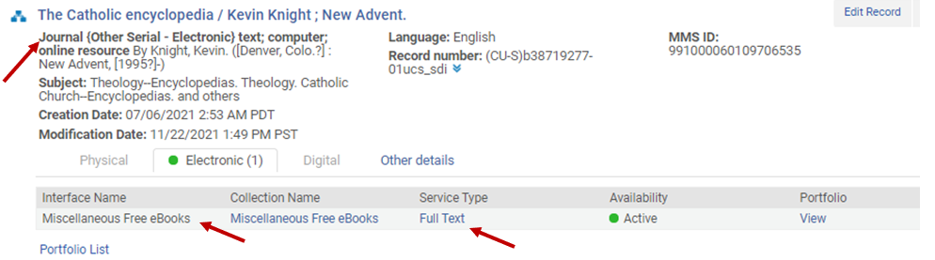

1. MS will catalog database (i.e., add a bib to the NZ).
   1. Search for and identify electronic portfolio or collection PID. 
   2. Add public notes and URLs as needed to the electronic portfolio or collection.
   3. Link the electronic portfolio or collection record to the bib.
   4. Relink PO lines, if needed.
   5. Delete redundant bibs.

New databases (open access):

1. MS usually receives cataloging requests for these directly.
2. MS will activate an existing CZ portfolio or electronic collection, or create a local one.
3. MS will catalog database and link the portfolio or electronic collection record to the bib, if needed.

New databases or ejournal aggregator (analyzed):

1. CARS will activate the collection and portfolios if in the CZ. If not in the CZ, CARS will create an electronic collection record and electronic portfolios before sending to MS for cataloging.
2. CARS may create a PO line for the database.
3. CARS will send cataloging request to MS via email.
4. MS will catalog database and link electronic collection record as needed.
5. MS will move PO lines if needed.
6. MS will catalog analytics.

**\*Changing database collection records to full text service:**

If an electronic record for a database was initially created without full text service, it is possible to add full text service later.

When editing the collection record, go to the General tab to change the Type.

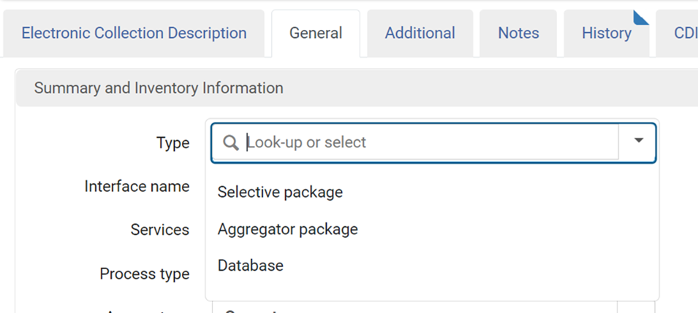

Go to the Additional tab, scroll down to the bottom to Services, click “add local service” and choose full text or selected full text, and save.  Then go to the 3-dot menu for the full text service just created and choose ‘Portfolio list’ to add your portfolios.  Then choose “Activate” to activate portfolios:

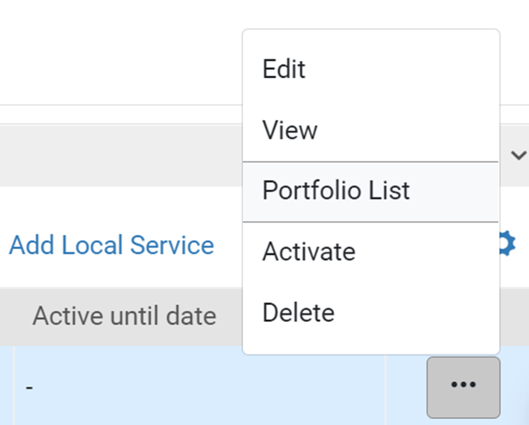

Save collection changes.