Open Access e-resource cataloging in Alma
Created 7/23/2021

See this page for general e-resource guidance: https://ucsdlibrary.atlassian.net/wiki/spaces/msdstaff/pages/1104839105/E-resource+cataloging+workflows

Open Access materials will often not have a CZ portfolio activated by CARS since they do not do any purchasing. Because of this, MS catalogers will need to do more searching in the Alma CZ for relevant portfolios.

Contents:
Searching
No CZ portfolio available
CZ portfolio available
CZ bib record needs to be replaced with an OCLC one

Example for this guide: 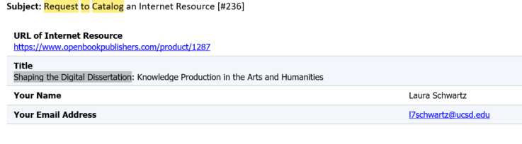
Searching
Search for a relevant bib in the UCSD IZ/UC NZ:
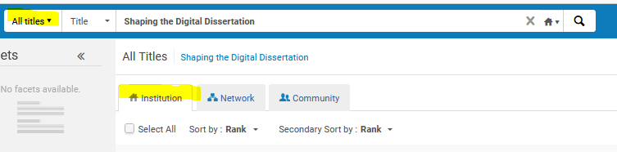
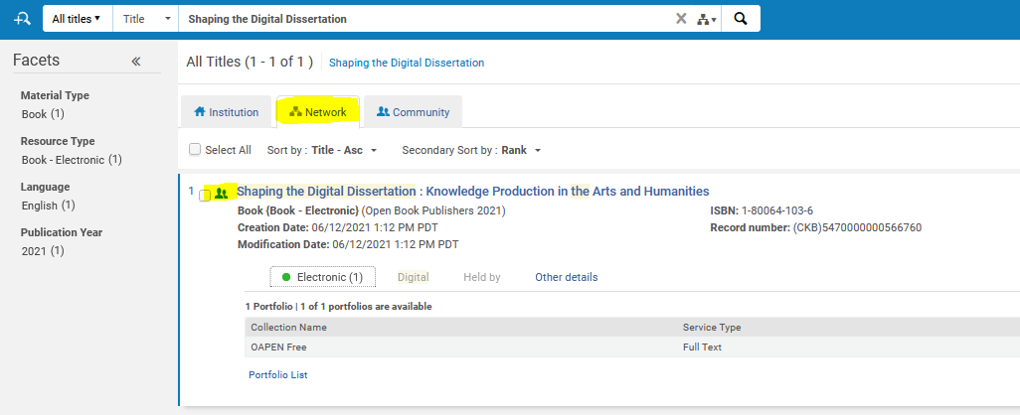
In this case, we see that we don’t have a bib or portfolio in the UCSD IZ for this, but there is a bib and portfolio in the UC NZ, both of which are part of the Alma Community Zone. In this case, the portfolio is from CDL/SCP (you can tell because it’s in the “electronic” section in the NZ view). We can also see that the CDL portfolio is for the OAPEN platform, and our book is for a Open Book publishers.

Search the CZ for a relevant portfolio:
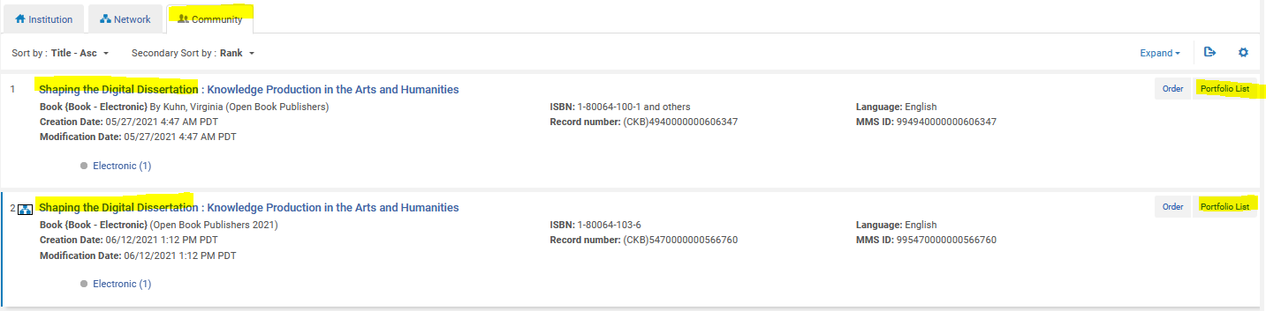
You’ll need to open the “portfolio list” for each of these to check which platform is available:
If none the portfolios available in the CZ is for the item in hand:

Export an OCLC bib into the UC NZ and standalone portfolio in the UCSD IZ

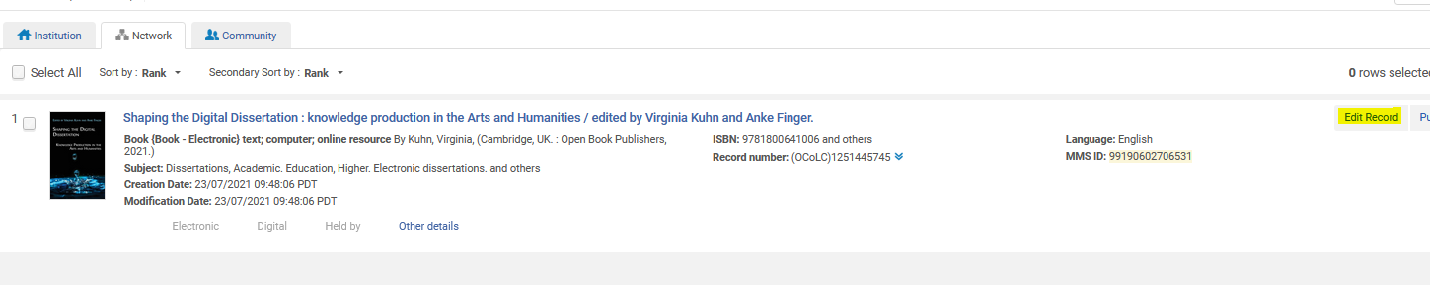
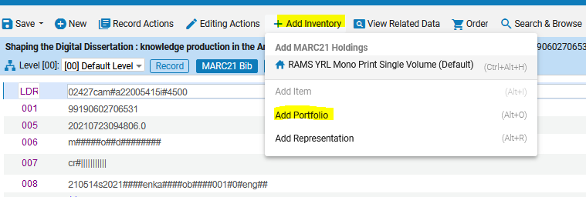
Always select “use existing title”
e-ISSN/e-ISBN are optional
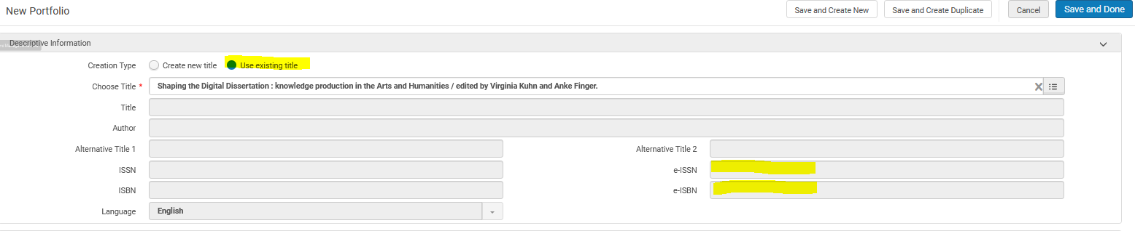

For now, most OA portfolios will be “standalone” and this option can be selected when in doubt.
Interface name can be left blank for now
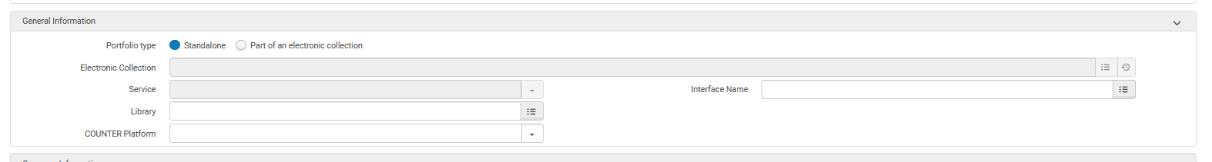

Coverage information is for serials only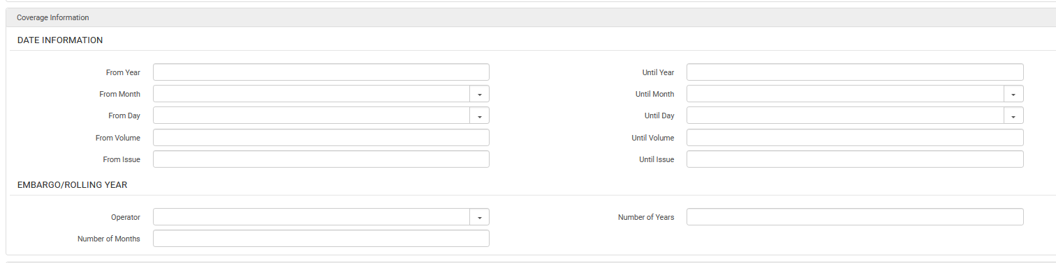
Add the url and select the right material type
“Proxy enabled” should always be “no”
“Availability status” should always be “active”
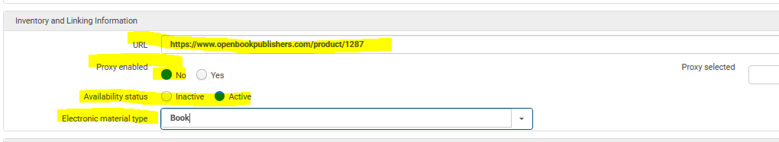
For now use whatever 856$z text you find on the e-resources tracking page in the “public note”
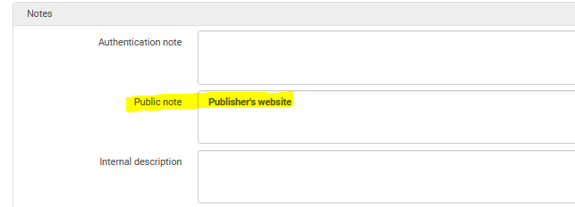

Go back to the top of the page and click “save and done”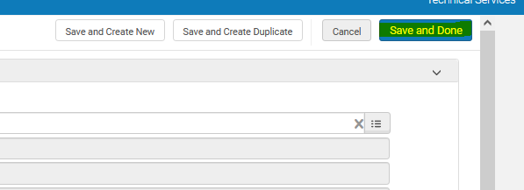
After saving the portfolio you’ll be brought back to the Metadata editor, make sure you save and release the bib
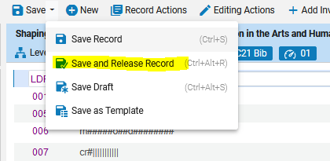
Do a new search for the title in the IZ, you should have an NZ linked bib record with an electronic portfolio set to “active.”
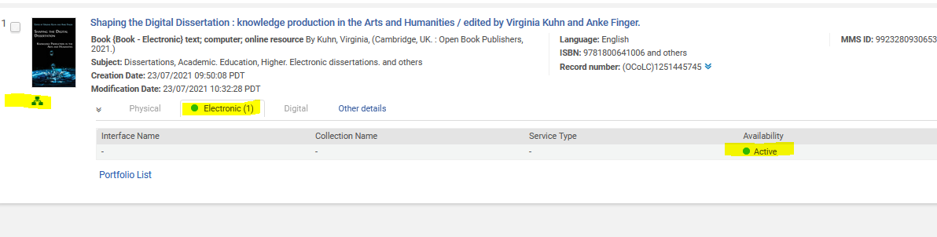

If a CZ portfolio is available for your item:

Check the linking information using the 3-dot menu
If the link matches, click on “activate”:
No need to select a library or collection for now:
Then click on the title to view the bib record: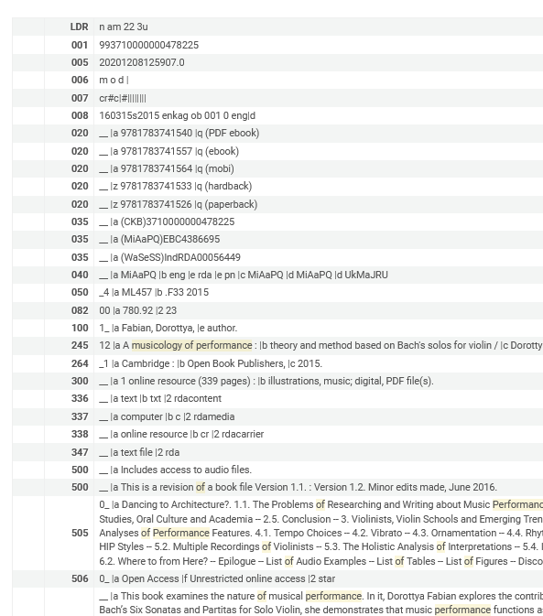
If the record looks ok, then view it in the IZ just to be sure it looks right. In this case the interface and collection name will be filled out since they’re coming from the CZt:
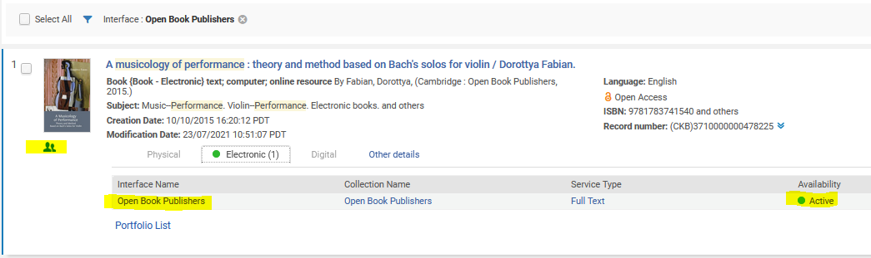
If the record is skimpy and no other record exists in the UCSD IZ or UC NZ, export a new record from OCLC, and re-link the CZ portfolio to that bib. Start by viewing the portfolio:
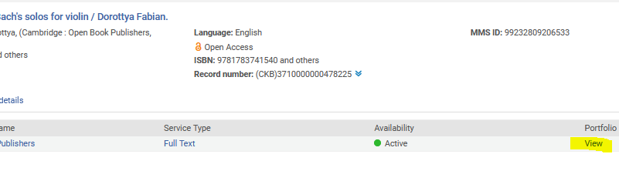
Then click on relink:

Then choose your title:
You’ll get a regular Alma search box:
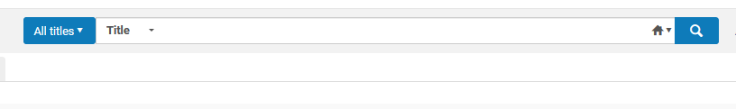
Select the title you want:
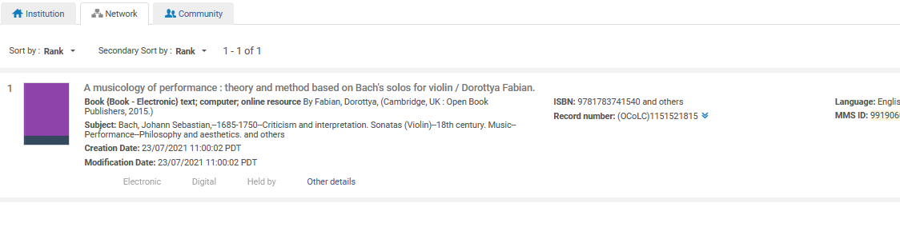
Review the confirmation message:
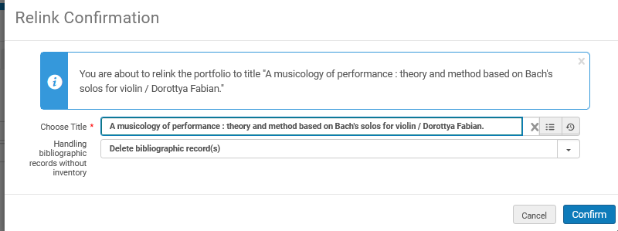
You are allowed to select “delete bibliographic records” only when relinking a CZ portfolio to a new bibliographic record.

You’ll be brought back to the portfolio screen, click save just to be safe:
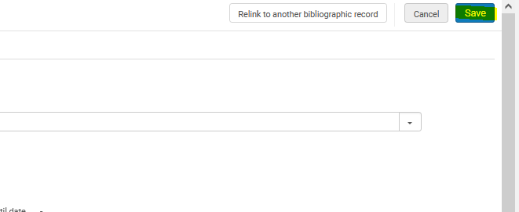
Do a new search in the IZ to confirm:
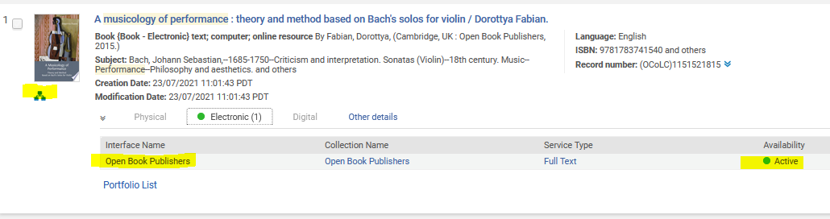
Note that the bib is now linked to the NZ instead of CZ but the CZ interface, collection, and service type are still in place.

