How to batch delete/restore portfolios in Alma
This document outlines 2 ways to delete and/or remove portfolios in bulk, and also how to restore batch deleted portfolios in Alma.
How to delete/remove portfolios in bulk in Alma
It's not possible to remove portfolios from a local collection or set them back to a standalone status. However, you can deactivate the portfolios or move them to another collection.
If you want to delete the portfolios entirely, you can do it one of two ways:
- Moving the portfolios into a dummy local collection and then deleting the collection.
OR
- Using the Portfolio loader.

Using the Portfolio loader:
Search for the collection with the portfolios to be deleted.
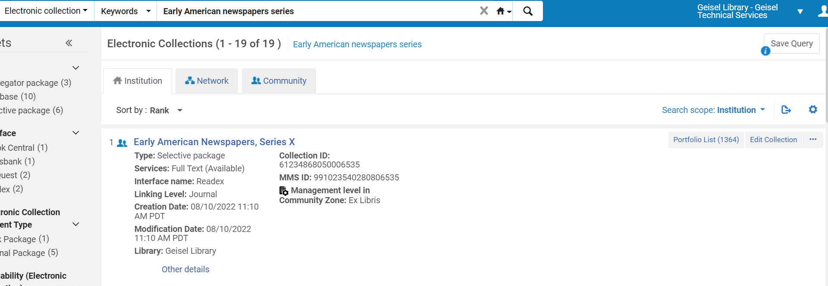
Click on Export List in the upper right corner: and create a spreadsheet with TITLE, and PORTFOLIO_PID.
Choose Edit Collection, Additional tab, and scroll to the bottom for Services. Click on the 3-dot menu and choose Edit.
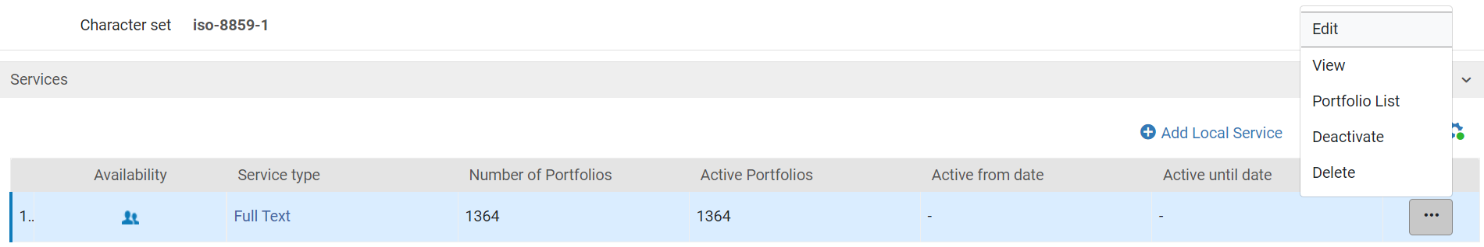
Choose the Portfolios tab and click on Load portfolios.
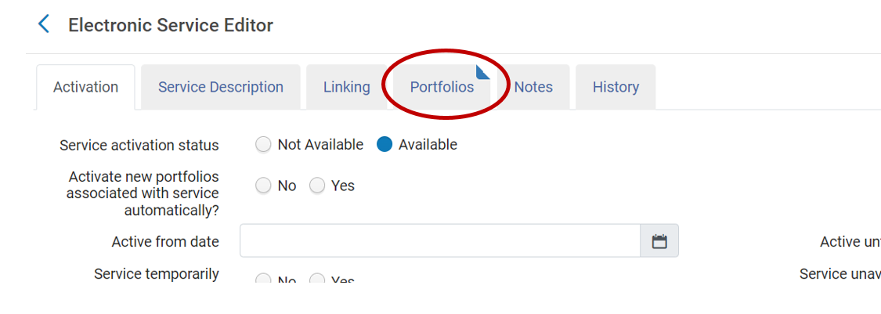

Fill out the Activation wizard: File Upload as follows:
- Bibliographic: Institution.
- Select file:
  - File: Find the file/spreadsheet with the portfolios to be deleted (the one you created in steps above).
  - Check: Portfolio Loader Format.
- Select Loading Policy: Incremental. VERY IMPORTANT: You must choose “Incremental.” If you choose “Complete”, you will wipe out all the portfolios NOT in your spreadsheet!
- Select Action:
  - Choose operation: Delete.
  - Handling bibliographic records without inventory: Always choose “Do nothing.”
- Select Validation Policy: Validate Offline.
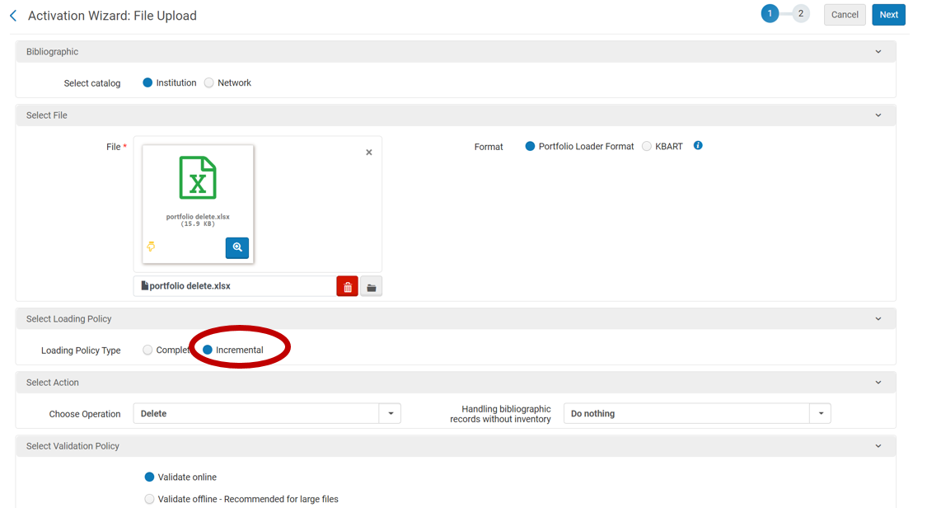
Click Next. Verify job, esp. the number of portfolios to be deleted. If correct, click Load. You will receive an email when your job is done. Keep this email since you may need the Job ID later.

How to restore deleted portfolios
If you accidentally delete a bunch of portfolios and need to restore them, you cannot restore them in bulk. They can only be restored one-by-one.
Go to Resources, Advanced Tools, and choose Manage deleted repository. Search for the portfolios by Job ID. Click Search.
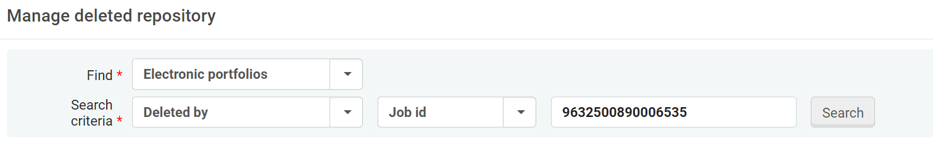
Click on Restore and Confirm your action.
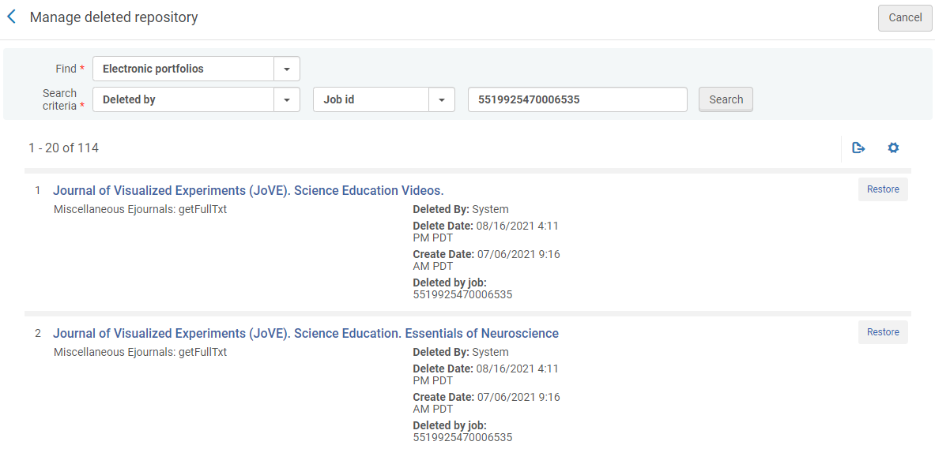
That’s it! You can use an Auto Mouse macro that can be used to help with this tedious process. MacroExpress doesn’t work.

