Electronic collections for UCSD databases and websites

Electronic collections in Alma are used to organize electronic resources for delivery and publication. Resources utilizing electronic collections can include electronic journals, databases, and e-books but this document addresses how to handle electronic collections for resources cataloged as integrating resources (IRs) only. For guidelines on how to handle collections for online analytics, see: Analytics procedure. For guidelines on collections for UCSD SC&A resources (including web archives), see: TBD. Instructions on cleaning up standalone portfolios and adding them to local collections are included at the end of the document.

One of the more challenging points of using electronic collections is how Alma defines a “database” and when to use an electronic collection versus an electronic portfolio for something that behaves and/or looks like a “database”. Alma has two options for linking “databases”:

- Collection Service type: Database
- Portfolio Electronic material type: Database

While this document attempts to provide guidelines for when to use a collection or portfolio for a database, treatment decisions will be determined on a case-by-case basis except for categories of materials (e.g., digitized manuscript collections) with locally established and standardized practices.

Creating and/or Activating Collection Records

Guiding principle: If there a CZ portfolio or collection record for a resource and it has the correct URL, use it regardless of Ex Libris’ supplied resource type (e.g., book, journal, database, website, etc.).

- If a database has a CZ portfolio or collection, activate as follows:

  - Websites and databases with CZ portfolios: Activate it, if it has the correct URL, regardless of Ex Libris’ supplied resource type.
  - Websites and databases with CZ collection records: Activate it, if it has the correct URL, regardless of Ex Libris’ supplied resource type.

- If a database does not have a CZ portfolio or collection, create and activate a local one as follows:

  - Websites without full text service (i.e., not in CZ): Create local electronic portfolio as resource type: Website.
  - Databases without full text service (i.e., not in CZ): Create local electronic collection record as resource type: Database. This can be changed later to full text service if needed.
  - Websites and databases with full text service (i.e., not in CZ): Create local electronic collection record as resource type: Aggregator or Selective package--Full text or Selected full text.

Example: Since Ex Libris’ has their own definitions and framework for bibliographic data, you may see things like this that don’t make sense. This resource is technically a website. In the cataloging world, websites are cataloged as “serials.” However, the cataloging treatment doesn’t dictate the resource type in Alma (it’s unclear how resource types are determined) so there could be portfolios or collection records in the CZ for any given resource. As it turns out, Ex Libris considers this an e-book. It has an e-book portfolio in the CZ and since the URL matches the cataloged resource, we would activate and use it. If there was no portfolio in the CZ, we would have created a local portfolio with resource type: Website, per 2a. above.

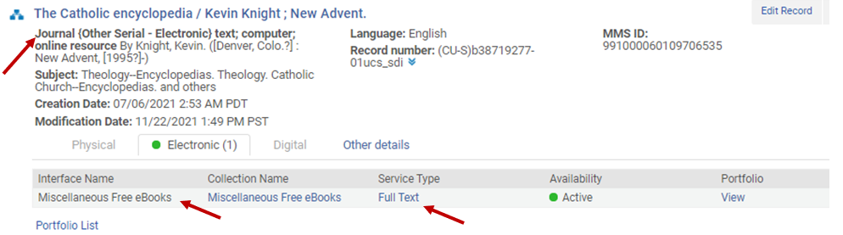

Cleaning up standalone portfolios and creating local collections

All of the 856 fields in our electronic resource records in Millennium were mapped to standalone electronic portfolios or collections without full text service when they migrated to Alma. Since standalone portfolios lack interface and collection names, it is a best practice to link them to collections whenever possible. Consult the E-resources tracking page for activated CZ and local collections.

- Electronic journals: Whenever possible, replace standalone portfolios with CZ ones to facilitate maintenance and URL persistence. If CZ portfolios are not available, add the standalone portfolios to existing CZ or local collections. If collections are not available, create a local one (see #2 below) when there are 8+ titles. Otherwise, add the standalone portfolio to the local collection called: Miscellaneous UC San Diego subscription online journals.

- Local collections for standalone portfolios: When CZ collections are not available for standalone portfolios (as collocated by 973s), create a local collection using the 973 as the name. Add the standalone portfolios to that collection. The local collection may or may not be linked to a collection level bib record. The full text service would be active.

- Local collections for open access journals: All CZ open access collections are activated for UCSD. If a CZ portfolio is not available for an open access journal, add the standalone portfolio to the local collection called: Open access resource; selected by the UC San Diego Library. (NOTE: This collection is for non-SC&A open access resources regardless of format)

